2020 - 21

Mohili-Aghai,Taluka-Shahapur,Dist-Thane

Vishwatmak Om gurudev College of Engineering

VJMAT’s

**Department of Computer Engineering**

Prof. Swati Hojage.

Guided By

Seat No: (

)

Harshad Patil

Seat No: (

)

Saimohan Sahu

Seat No: (

)

Saquib Ansari

Submitted By

Morse Code Converter Softwear”

on

Mini Project Report



0

2020 – 2021

Mohili-Aghai,Taluka-Shahapur,Dist-Thane

**Vishwatmak Om gurudev College of Engineering**

VJMAT’s

**Department of Computer Engineering**

Prof. Swati Hojage.

Guided By

Seat No: (

)

Harshad Patil

Seat No: (

)

Saimohan Sahu

Seat No: (

)

Saquib Ansari

Submitted By

Computer Engineering

in

Bachelor of Engineering

For the Degree of

in Partial Fulfillment of the Requirements

Mini Project Report Submitted



1

Place: VOGCE (Aghai)

Date:

External Examiner

Principal

Prof.

Internal Examiner

Head (Computer Engg.)

Prof. Swati Hojage

Prof.Anup Maurya

Project Guide

Prof. Swati Hojage

Engineering of Mumbai University Mumbai during the academic year 2020-2021.

guidance in partial fulfillment of the degree of Bachelor of Engineering in Computer Science

” has been carried out by **Saquib Ansari,Saimohan Sahu** and **Harshad Patil.** under my

This is to certify that the mini project entitled “Morse code converter"

CERTIFICATE

2

(Exam Seat No:

)

Harshad Patil

(Exam Seat No:

)

Saimohan Sahu

(Exam Seat No:

)

Saquib Ansari

ways.

work towards an effective project alive in me and guided in their own capacities in all possible

Department who directly or indirectly kept the enthusiasm and momentum required to keep the

support. We would also like to thank all other faculty members of the Computer Engineering

Dr.Manoj Chavan, Principal, Vishwatmak Om gurudev College of Engineering for his valuable

always helped us and inspired us during completion of the Project. Our special thanks to

immense satisfaction to express our profound gratitude towards our Family and Friends who

our Mini Project on “Morse code converter”. It needed a great moment of

suggestions and guidance throughout the course of study and timely help given in the progress of

Prof. Swati Hojage and Head of Computer Department, Prof. Anup Maurya for his valuable

It is our privilege to acknowledge with deep sense of gratitude towards our project guide

Acknowledgement

3

4

5

7

Conclusionononon

19

6

Coding

18

5

Advantages & Disadvantages

17

4

Project Design

13

Content

3.2 Decryption

3.1 Encryption

11

3.

Importance

10

2.

Objectives

9

1.

Introduction

8

Chapter

Abstract

7

Topic

Page No.

6

**Abstract :-**

This research paper proposes the Morse code which is the earliest method used in Radio Telegraphy. Because of advanced telecommunication systems it is considered to be an outdated technique. Travelers, Sailors, Villagers from remote areas where cellular networks are almost inaccessible would need a most reliable mode of communication. But, then there are chances that they might not able to handle Morse code, because of its complex encoding pattern and ON-OFF J38 Keying technique. So, in order to facilitate communication they can use this device where only the knowledge of alphabets and numbers is sufficient. With this design they will able to telegraph important messages with alphanumeric keypad and also read the messages from LCD screen. Using microcontroller this device can encode and decode messages of International Morse Code.

7

**Chapter 1:** **INTRODUCTION**

Morse code is a method of transmitting string information into a series of dots[.] and dashes[-] encrypting a message between two entities and so making communication possible between two parties. And we are going to have the fun task of doing just that.

I will be using a simple console application to represent the use of Morse code. At first we will need to define a dictionary to be able to communicate. Find the Morse code value of the letter we want to type and instantiate a dictionary element and the reason for doing so is that we will not have to use all of the redundant if statements or case statements thus increasing our calculation speeds.

8

1. The students will be able to identify Morse Code as a form of communication and explain how it was used.
2. The students will be able to create and decipher short messages using Morse Code and a key to assist them.
3. The students will be use an online Morse Code translator to create longer more detailed messages.

**Chapter 2: OBJECTIVES**

9

-:

iBefore the invention of Morse Code and the telegraph, messages were still handwritten and carried by horseback. Morse Code changed the way we communicated. In the time of its invention, it was the fastest long distance form of communication.

Morse Code allowed for ships at sea to communicate over long distances using large lights. Morse Code was especially pivotal during the second World War because it greatly improved the speed of communication. Naval war ships were able to communicate with their bases and provide critical information to each other. War planes also used Morse Code to detail locations for enemy ships, bases, and troops and relay them back to headquarters.

Morse Code has also been used as an alternative form of communication for people with disabilities or whom have their abilities to communicate imparied by stroke, heart attack, or paralysis. There have been several cases where individuals have been able to use their eyelids to communicate in Morse Code by using a series of long and quick blinks to represent that dots and dashes.

**Chapter 3: IMPORTANCE**

10

One of the most famous examples of a **cipher** in regular use is **Morse Code** (which is not a **code**, but rather a **cipher**). **Morse Code** has the benefit that it can be transmitted in several ways, such as written, by sound or by light. Each letter is replaced by a series of dots and dashes as given by the key below. One of the most famous examples of a **cipher** in regular use is **Morse Code** (which is not a **code**, but rather a **cipher**). **Morse Code** has the benefit that it can be transmitted in several ways, such as written, by sound or by light. Each letter is replaced by a series of dots and dashes as given by the key below. One of the most famous examples of a **cipher** in regular use is **Morse Code** (which is not a **code**, but rather a **cipher**). **Morse Code** has the benefit that it can be transmitted in several ways, such as written, by sound or by light. Each letter is replaced by a series of dots and dashes as given by the key below.

**Chapter 3.1:- Encryption**

One of the most famous examples of a **cipher** in regular use is **Morse Code** (which is not a **code**, but rather a **cipher**). **Morse Code** has the benefit that it can be transmitted in several ways, such as written, by sound or by light. Each letter is replaced by a series of dots and dashes as given by the key below.

**Chapter 3.2:- Decryption**

You can type **Morse code** into the Input box using "." for a dot and "-" or "_" for a dash. Letters are separated by spaces and words by "/" or "|". The text translation will appear in the output box. If a letter cannot be translated a "#" will appear in the output.

11

w

12

Screenshots:

**Chapter 4: PROJECT DESIGN**

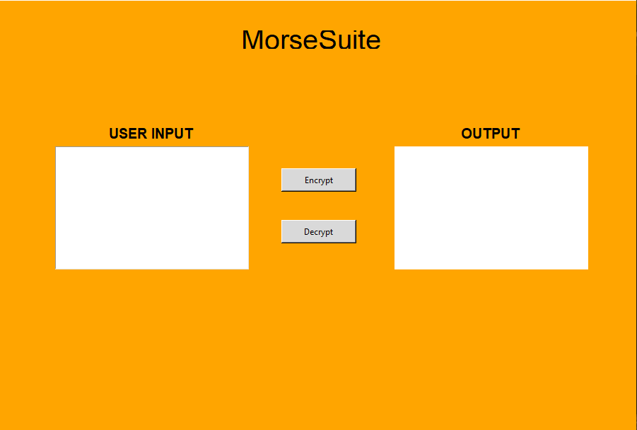

13

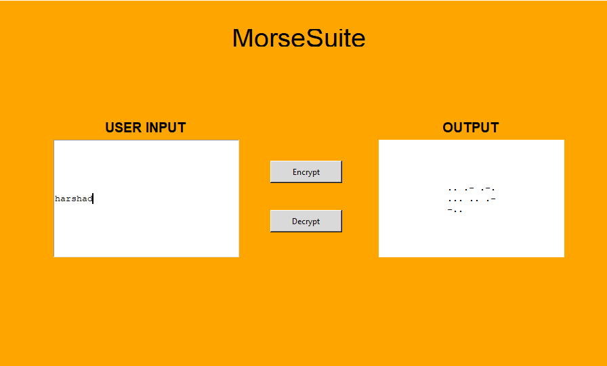

14

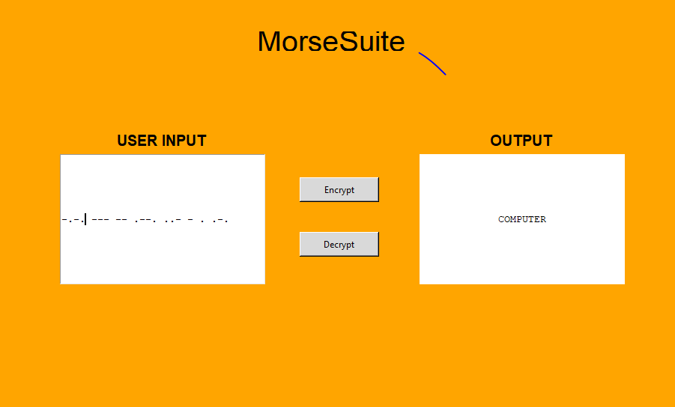

15

**Chapter 5: Advantages & Disadvantages**

**Advantages of Morse Code:-**

In the modern age, the Morse code is still as relevant as it was in the days of old. Here are the advantages of Morse code.

**1.Cheap**  
Use of the Morse code is a cheaper way to send information over long distances. For over 150 years since information transmits easily over longer distance via radio waves in an easy and cheap way.

**2.Wireless**  
The lack of wires has made the application of Morse code diverse since it is silently sent and received at any desirable speed. Its wireless nature makes Morse code receivable though any visible means.

### Disadvantages of Morse Code:-

During the war, the Morse code got widely applied in the World Wars to ensure that neither side could decipher their secrets. Below are some of the other disadvantages of Morse Code.

**1. Learning the Morse Code**  
The Morse code is not an easy concept to understand and it is largely a reserve of a few radio programmers. The concept is not easy to learn either and the machines are in scarcity in the modern age. It is also tough to apply in the modern era that is

**2. Time Consuming**  
Sending and decoding of the Morse code is time consuming and it is the reason many people put it off. When the transmission of information is at high speeds, the

**3. Interruption**  
The Morse code is easy to intercept and it is no longer a reliable option compared to the recent technological inventions. Better technologies are in a position to provide better channels of passing information.

16

**Chapter 6: CODING**

import encryption as cipher  
import decryption as decipher  
  
try:  
 import Tkinter as tk  
except ImportError:  
 import tkinter as tk  
  
import gui_support  
  
def vp_start_gui():  
 *'''Starting point when module is the main routine.'''* global val, w, root  
 root = tk.Tk()  
 top = Toplevel1 (root)  
 gui_support.init(root, top)  
 root.mainloop()  
  
w = None  
def create_Toplevel1(root, *args, **kwargs):  
 *'''Starting point when module is imported by another program.'''* global w, w_win, rt  
 rt = root  
 w = tk.Toplevel (root)  
 top = Toplevel1 (w)  
 gui_support.init(w, top, *args, **kwargs)  
 return (w, top)  
  
def destroy_Toplevel1():  
 global w  
 w.destroy()  
 w = None  
  
class Toplevel1:  
 def __init__(self, top=None):  
 *'''This class configures and populates the toplevel window.  
 top is the toplevel containing window.'''* _bgcolor = '#d9d9d9' # X11 color: 'gray85'  
 _fgcolor = '#000000' # X11 color: 'black'  
 _compcolor = '#d9d9d9' # X11 color: 'gray85'  
 _ana1color = '#d9d9d9' # X11 color: 'gray85'  
 _ana2color = '#ececec' # Closest X11 color: 'gray92'  
  
 top.geometry("902x600+385+154")  
 top.minsize(148, 1)  
 top.maxsize(1924, 1030)  
 top.resizable(1, 1)  
 top.title("CryptoSuit")  
 top.configure(background="orange")  
  
 self.text1 = tk.Entry(top)  
 self.text1.place(relx=0.089, rely=0.333,height=174, relwidth=0.304)  
 self.text1.configure(background="white")  
 self.text1.configure(font="TkFixedFont")  
 self.text1.configure(foreground="#000000")  
 self.text1.configure(insertbackground="black")  
  
 self.text1_1 = tk.Message(top)  
 self.text1_1.place(relx=0.621, rely=0.333,height=174, relwidth=0.304)  
 self.text1_1.configure(background="white")  
 self.text1_1.configure(font="TkFixedFont")  
 self.text1_1.configure(foreground="#000000")  
 self.text1_1.configure(highlightbackground="#d9d9d9")  
 self.text1_1.configure(highlightcolor="black")  
 self.text1_1.configure(width=100)  
   
 def call():  
 plain_text =self.text1.get().upper()  
 ans=cipher.encryptor(plain_text)  
 #print(ans)  
 self.text1_1.configure(text=ans)  
  
 def get():  
 encrypted_text = self.text1.get()  
 x=decipher.decryptor(encrypted_text)  
 self.text1_1.configure(text=x)  
  
 self.Button1 = tk.Button(top)  
 self.Button1.place(relx=0.443, rely=0.383, height=33, width=106)  
 self.Button1.configure(activebackground="#ececec")  
 self.Button1.configure(activeforeground="#000000")  
 self.Button1.configure(background="#d9d9d9")  
 self.Button1.configure(disabledforeground="#a3a3a3")  
 self.Button1.configure(foreground="#000000")  
 self.Button1.configure(highlightbackground="green")  
 self.Button1.configure(highlightcolor="black")  
 self.Button1.configure(pady="0")  
 self.Button1.configure(text="Encrypt",command=call)  
  
 self.Button1_2 = tk.Button(top)  
 self.Button1_2.place(relx=0.443, rely=0.5, height=33, width=106)  
 self.Button1_2.configure(activebackground="#ececec")  
 self.Button1_2.configure(activeforeground="#000000")  
 self.Button1_2.configure(background="#d9d9d9")  
 self.Button1_2.configure(disabledforeground="#a3a3a3")  
 self.Button1_2.configure(foreground="#000000")  
 self.Button1_2.configure(highlightbackground="green")  
 self.Button1_2.configure(highlightcolor="black")  
 self.Button1_2.configure(pady="0")  
 self.Button1_2.configure(text='''Decrypt''',command=get)  
  
 self.Label1 = tk.Label(top)  
 self.Label1.place(relx=0.356, rely=0.067, height=26, width=242)  
 self.Label1.configure(background="orange")  
 self.Label1.configure(disabledforeground="#a3a3a3")  
 self.Label1.configure(foreground="black")  
 self.Label1.configure(text='''MorseSuite''',font=("arial",30))  
  
 self.Label2 = tk.Label(top)  
 self.Label2.place(relx=0.1, rely=0.283, height=26, width=252)  
 self.Label2.configure(background="orange")  
 self.Label2.configure(disabledforeground="#a3a3a3")  
 self.Label2.configure(foreground="#000000")  
 self.Label2.configure(text='''USER INPUT''',font=("arial",15,'bold'))  
  
 self.menubar = tk.Menu(top,font="TkMenuFont",bg=_bgcolor,fg=_fgcolor)  
 top.configure(menu = self.menubar)  
  
 self.Label3 = tk.Label(top)  
 self.Label3.place(relx=0.632, rely=0.283, height=26, width=252)  
 self.Label3.configure(background="orange")  
 self.Label3.configure(disabledforeground="#a3a3a3")  
 self.Label3.configure(foreground="#000000")  
 self.Label3.configure(text='''OUTPUT''',font=("arial",15,'bold'))  
  
if __name__ == '__main__':  
 vp_start_gui()

import dictionary as dict  
  
# Function used to encrypt plain text into morse code  
def encryptor(text):  
 encrypted_text= ""  
 for letter in text:  
 if letter != " ":  
  
 #Accessing the values of letters entered and seperating each by a space and storing into a variable  
 encrypted_text= encrypted_text + dict.MORSE_CODE_DICT.get(letter) + " "  
 else:  
 #Providing double space if it encounters a space within letters or words  
 encrypted_text += " "  
 print("The morse code is : ",encrypted_text)  
 return(encrypted_text)

import dictionary as dict  
  
#A function used to decrypt morse code into plain text  
def decryptor(text):  
  
 #Adding a space at the end so that it can access the last letter  
 text += " "  
   
 #Creating list of keys and values of dictionary  
 key_list= list(dict.MORSE_CODE_DICT.keys())  
 val_list= list(dict.MORSE_CODE_DICT.values())  
  
 #To store morse code in a temp variable  
 morse_code=""  
 plain_text=""  
 for letters in text:  
 if letters != " ":  
 morse_code +=letters  
 space_found=0  
 else:  
 space_found += 1  
 if space_found==2:  
 plain_text += " "  
 else:  
   
 #Accessing the index of the value i.e, morsecode and then from that index finding the key at that index  
 plain_text= plain_text + key_list[val_list.index(morse_code)]  
   
 #Again making morse_code empty so that it can store next morse in it  
 morse_code= ""   
 print("The plain text is: ",plain_text)  
 return(plain_text)

# Dictionary consisting of morse code of alphabates,numbers and some symbols  
MORSE_CODE_DICT = {   
 'A':'.-',   
 'B':'-...',   
 'C':'-.-.',   
 'D':'-..',   
 'E':'.',   
 'F':'..-.',   
 'G':'..',  
 'I':'..--.',  
 'H':'..',  
 'J':'.---',   
 'K':'-.-',   
 'L':'.-..',   
 'M':'--',   
 'N':'-.',   
 'O':'---',   
 'P':'.--.',   
 'Q':'--.-',   
 'R':'.-.',   
 'S':'...',   
 'T':'-',   
 'U':'..-',   
 'V':'...-',   
 'W':'.--',   
 'X':'-..-',   
 'Y':'-.--',  
 'Z':'--..',   
 '1':'.----',   
 '2':'..---',   
 '3':'...--',   
 '4':'....-',   
 '5':'.....',   
 '6':'-....',   
 '7':'--...',   
 '8':'---..',   
 '9':'----.',   
 '0':'-----',   
 ',':'--..--',  
 '.':'.-.-.-',   
 '?':'..--..',   
 '/':'-..-.',  
 '-':'-....-',   
 '(':'-.--.',   
 ')':'-.--.-'  
 }

19

Chapter 7::Conclusion:

We have successfully developed morse code converter.

Since this is for security purposes that's why we used this technique,

Because of it is very difficult to crack & also it is end to end encrypted.

This is very easy to use ,when we'll type any information or message

It will convert into morse code and same for opposite.